**Ch4. Identifying and Selecting Systems Development Projects**

* 描述 the project identification and selection process.
* 描述 corporate strategic planning and information systems planning process.
* 說明 the relationship between corporate strategic planning and information systems planning.
* 描述 how information systems planning can be used to assist in identifying and selecting systems development projects.
* 分析 information systems planning matrices to determine affinity between information systems and IS projects and to forecast the impact of IS projects on business objectives.
* 描述 the three classes of Internet electronic commerce applications: business-to-consumer, business-to-employee, and business-to-business.

1. **Identifying and Selecting Systems Development Projects**

**IS development requests:**

* + To replace or to extend an existing system
  + To make a system more efficient and less costly to operate
  + To move it to a new operating environment
  + A formal planning group that identifies projects for improvement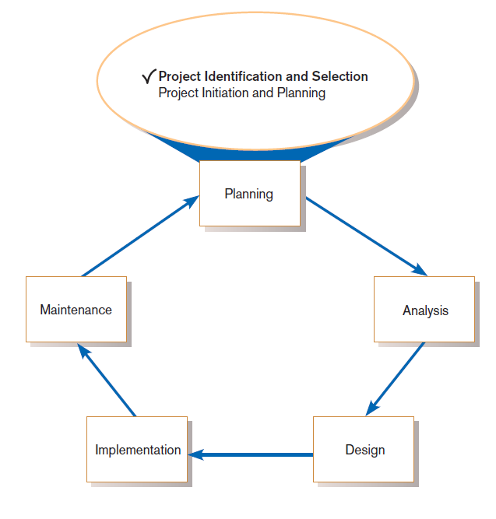

1. **The Process of Identifying and Selecting IS Development Projects**
2. **Identifying potential development projects**

* Identification from a stakeholder group
* Top-down source are projects identified by top management or by a diverse steering committee.
* Bottom-up source are project initiatives stemming from(源自) managers, business units, or the development group.
* The process varies substantially across organizations.

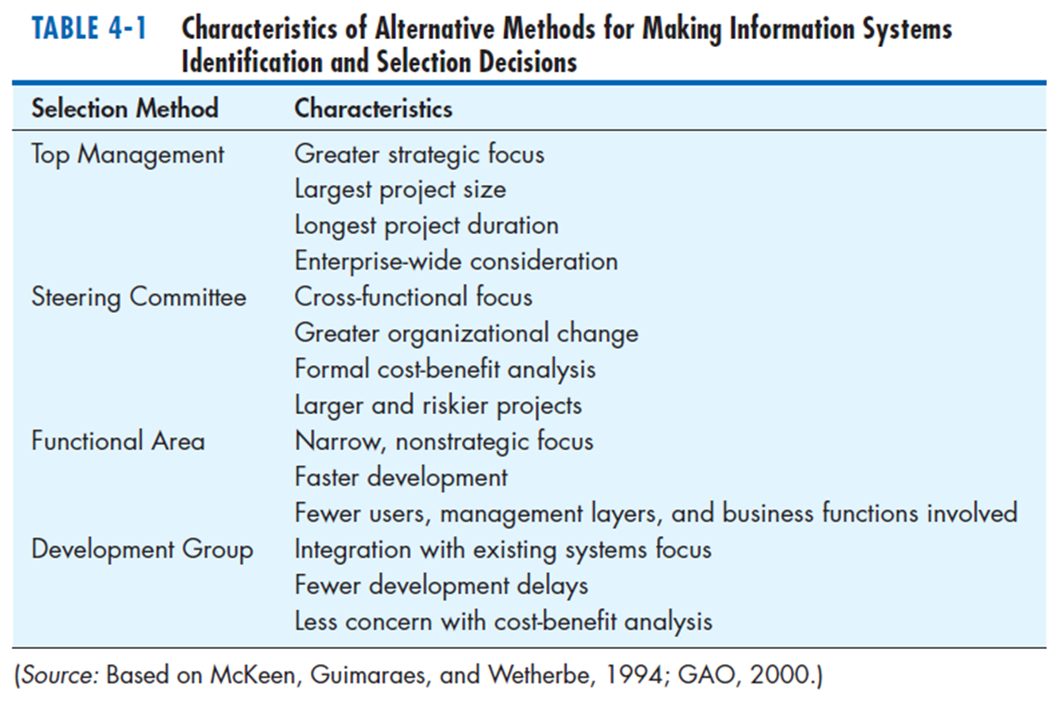

1. **Classifying and ranking IS development projects**

* Using value chain analysis or other evaluation criteria
* **Value chain analysis:** Analyzing an organization’s activities to determine where value is added to products and/or services and the costs incurred for doing so; usually also includes a comparison with the activities, added value, and costs of other organizations for the purpose of making improvements in the organization’s operations and performance
* IS projects that provide the greatest benefit to the value chain will be given priority over those with fewer benefits….

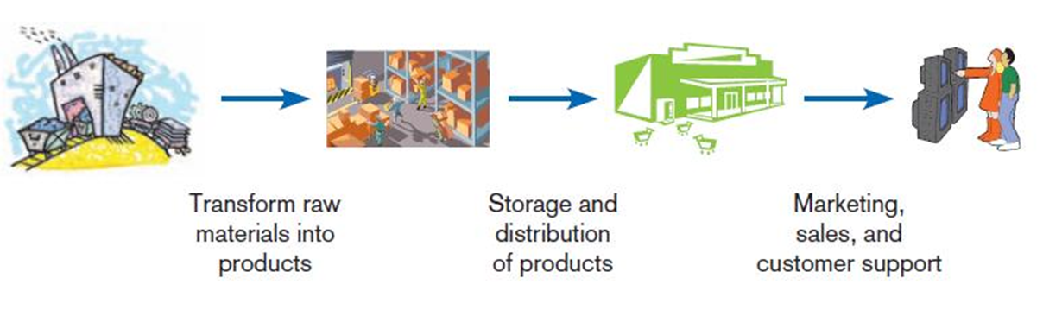

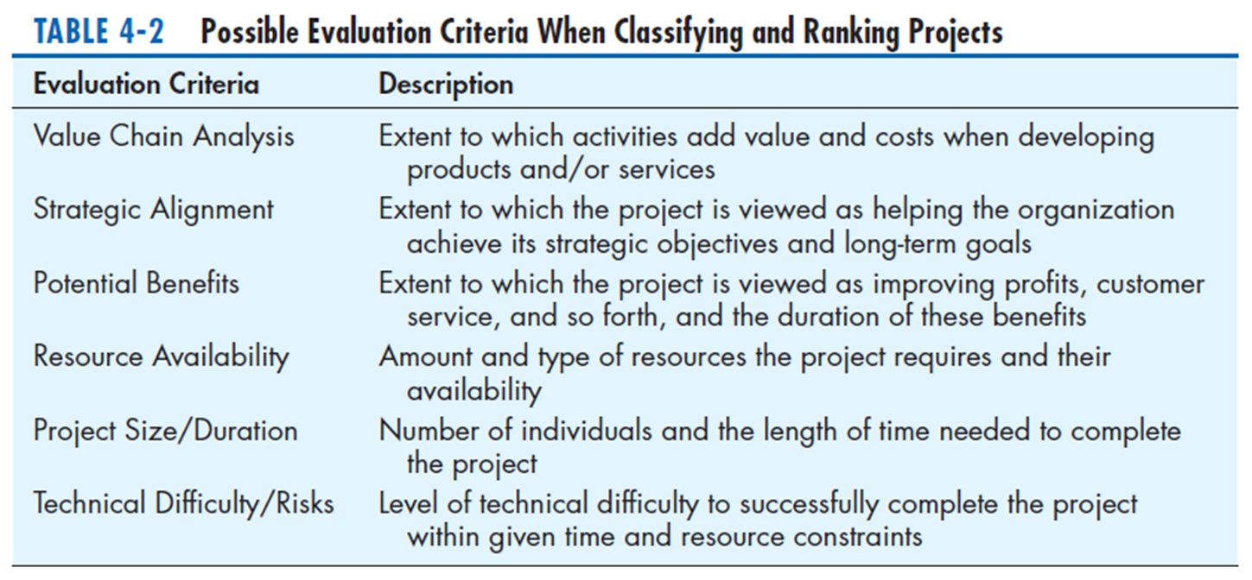

1. **Selecting IS development projects**

* Based on various factors
* Both short- and long-term projects considered
* Most likely to achieve business objectives selected
* A very important and ongoing activity
* Business conditions change over time
* Relative importance of any single project may substantially change

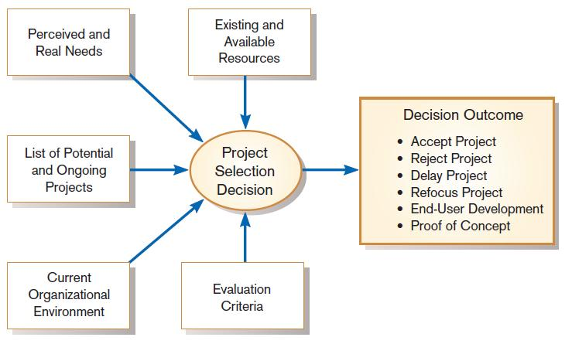

* One method for deciding among different projects or alternative designs
* For each requirement or constraint:

Score = weight X rating

* Each alternative: sum scores across requirements/constraints
* Alternative with highest score wins

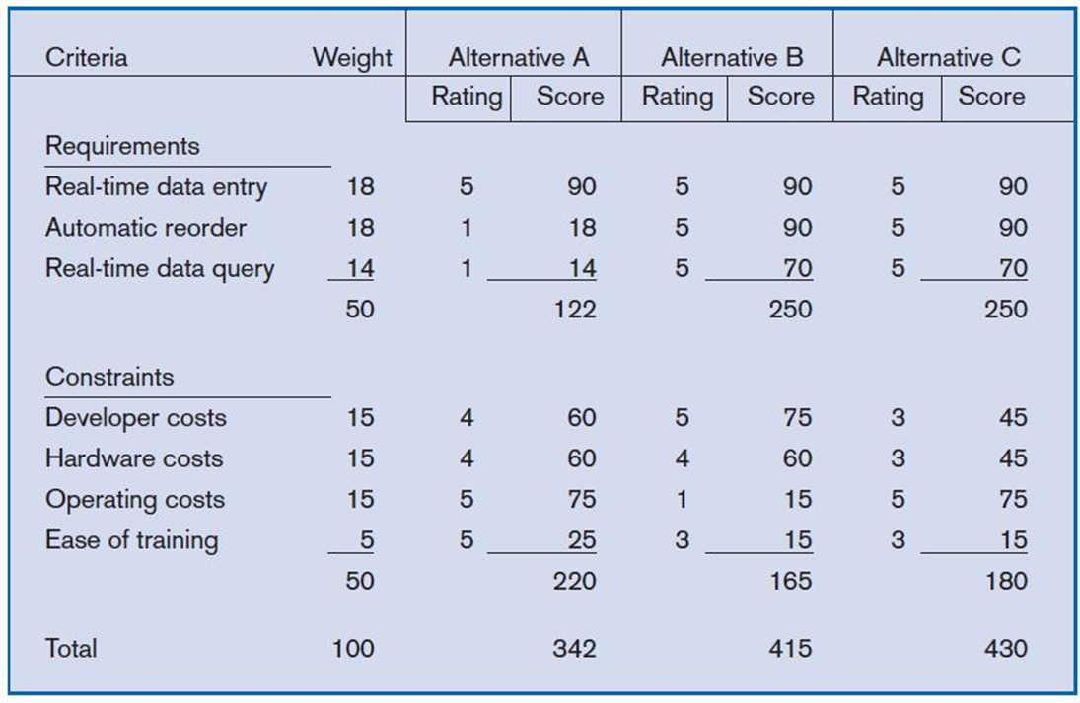

1. **Deliverables and Outcomes**
   * Primary deliverable from the first part of the planning phase is a schedule of specific IS development projects.
   * Outcome of this phase is the assurance that careful consideration was given to project selection and each project can help the organization reach its goals.
   * Incremental commitment(漸增承諾): a strategy in systems analysis and design in which the project is reviewed after each phase and continuation of the project is re-justified

* A selected project does not necessarily result in a working system

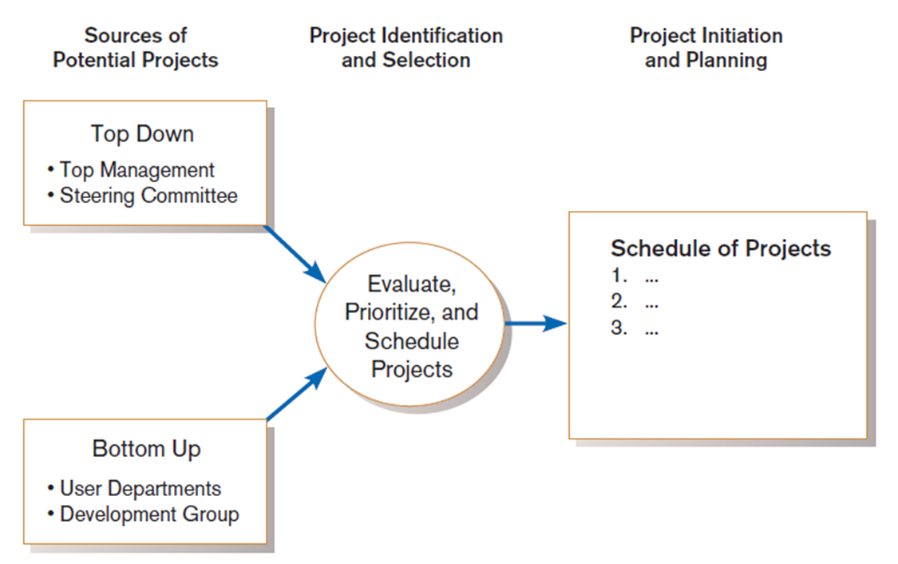

1. **Corporate and Information Systems Planning**
   * Changes of informational needs vs. changes of business processes

* e.g., A university change its procedure for registering students
  + To benefit from a planning-based approach for identifying and selecting projects, an organization must:
* Analyze its information needs thoroughly.
* Plan its projects carefully.

1. **Reasons for Improved Planning**
   * Increasing cost of information systems (40% of organizational expense)
   * Lack of cross-organizational applications and systems
   * Systems don’t address critical strategic problems
   * Too much data redundancy, lack of data quality
   * High system maintenance costs
   * Long application backlogs
2. **Corporate Strategic Planning**
   * 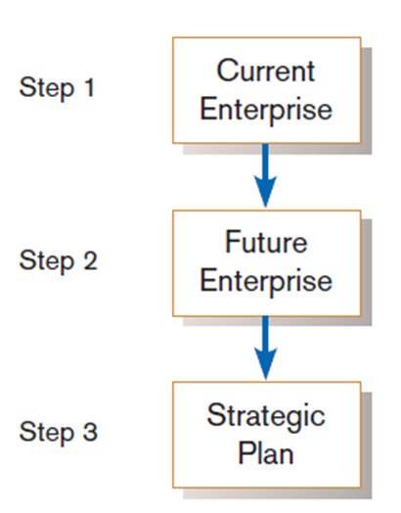Ongoing process that defines mission, objectives, and strategies of an organization
   * Corporate strategy involves:

* **Mission statement:**

a statement that makes it clear what business a company is in

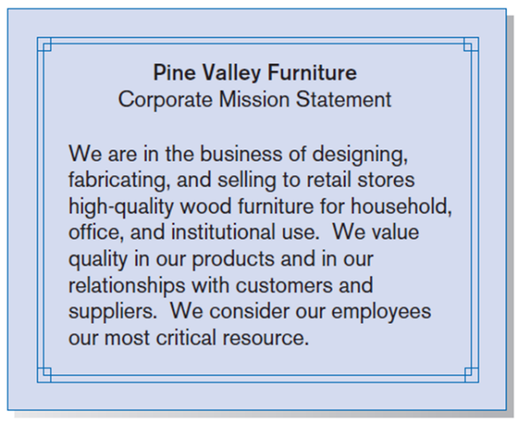

* **Objective statements:**

a series of statements that express an organization’s qualitative and quantitative goals for reaching a desired future position

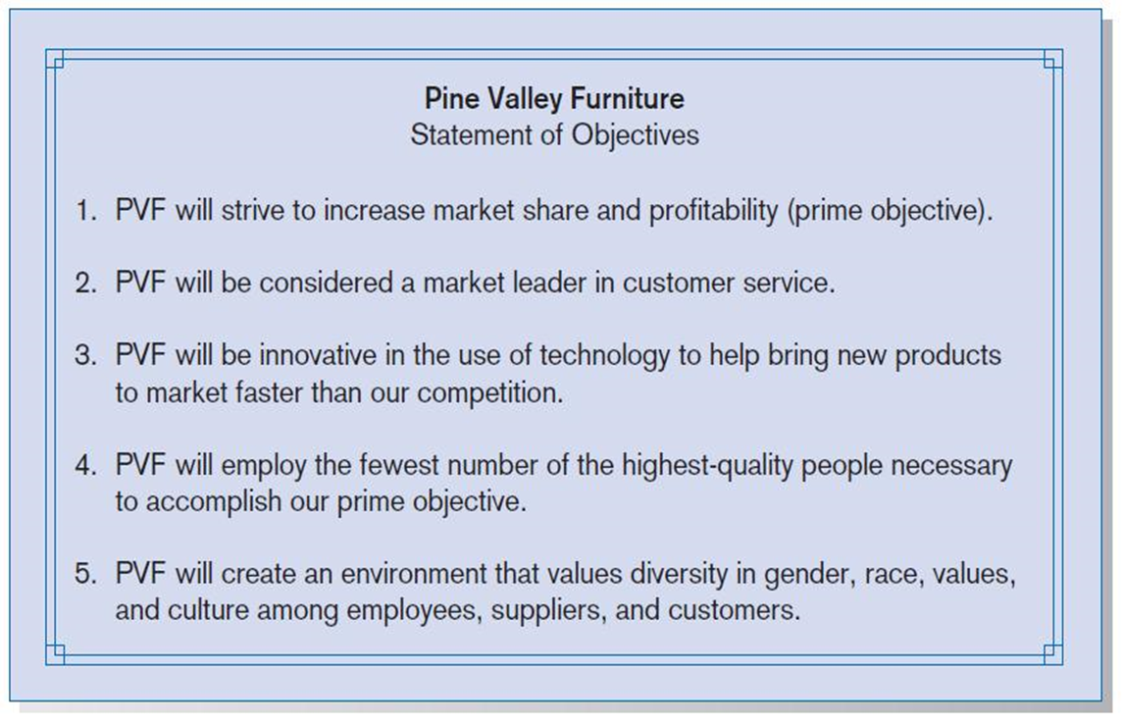

* **Competitive strategy:**

the method by which an organization attempts to achieve its mission and objectives

* Main types:
* Low-cost producer
* Product differentiation
* 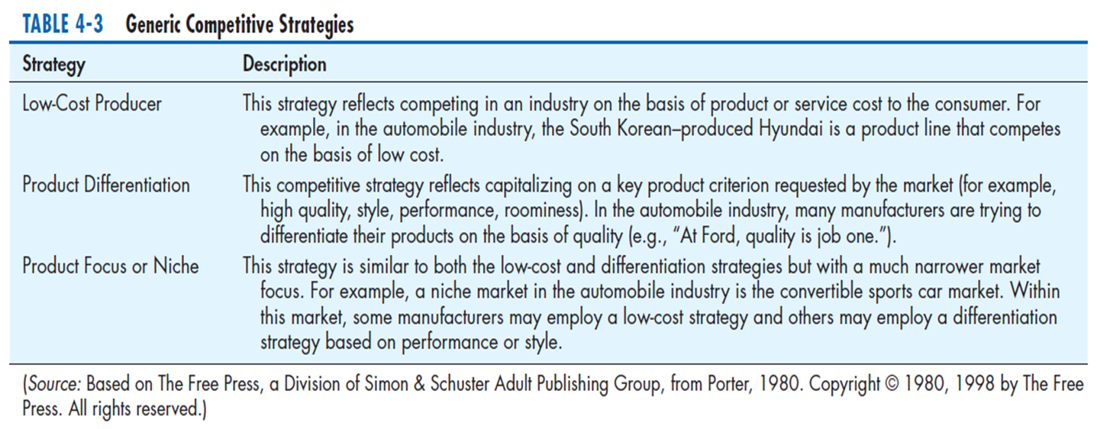Product focus or niche

1. **Information Systems Planning (ISP)**
   * An orderly means of assessing the information needs of an organization and defining the systems, databases, and technologies that will best meet those needs
   * ISP must be done in accordance(依照規則) with the organization’s mission, objectives, and competitive strategy.

* ISP is a top-down process: ISP must look at IS and IT in terms of how they help the business achieve its objectives
  + ISP: A **3-step** process
* To assess current IS-related assets
* To develop target blueprints of these resources
* To define a series of schedule projects to help move the organization from its current to its future desired state

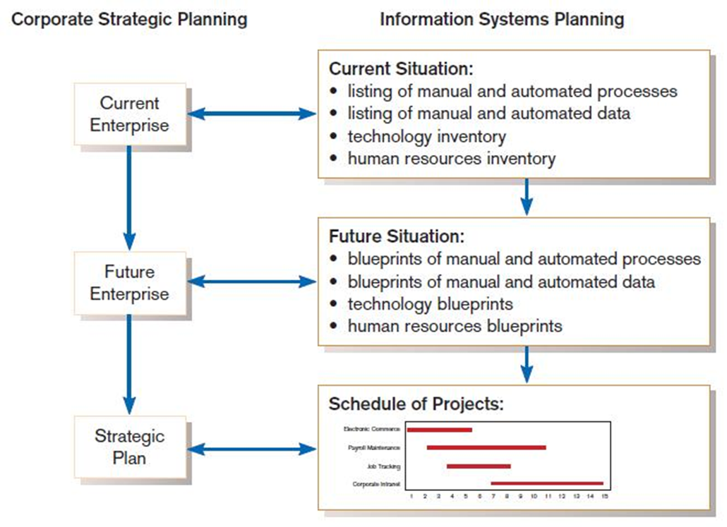

* + Numerous methodologies such as Business Systems Planning (BSP) and Information Engineering (IE) have been developed to support the ISP process; most contain the following 3 key activities
* Describing the current situation
* Describing the target situation, trends, and constraints
* Developing a transition strategy and plans

1. **Describing The Current Situation**
   * **Top-down planning** attempts to gain a broad understanding of IS needs of the entire organization

* Begins by conducting an extensive analysis of the organization’s mission, objectives, and competitive strategy and determining the information requirements needed to meet each objectives
* A high-level organizational perspective with active involvement of top-level management
* **Advantages:** broader perspective, improved integration, improved management support, better understanding
  + **Bottom-up planning** requires the identification of business problems and opportunities that are used to define projects
* Can be faster and less costly, so may be beneficial in certain circumstances
* Often fails to view the informational needs of the entire organization, resulting in disparate IS and DB that are redundant or not easily integrated without substantial rework
  + 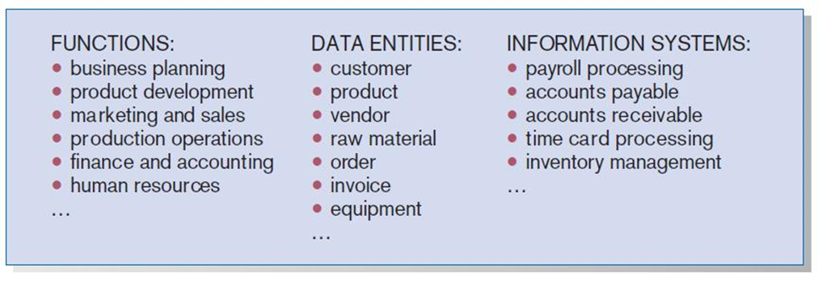Information that must be collected to represent the current situation include the identification of all organizational location, units, functions, processes, data (or data entities), and IS
  + **Functional Decomposition:** breaking high-level abstract information into smaller units for more detailed planning

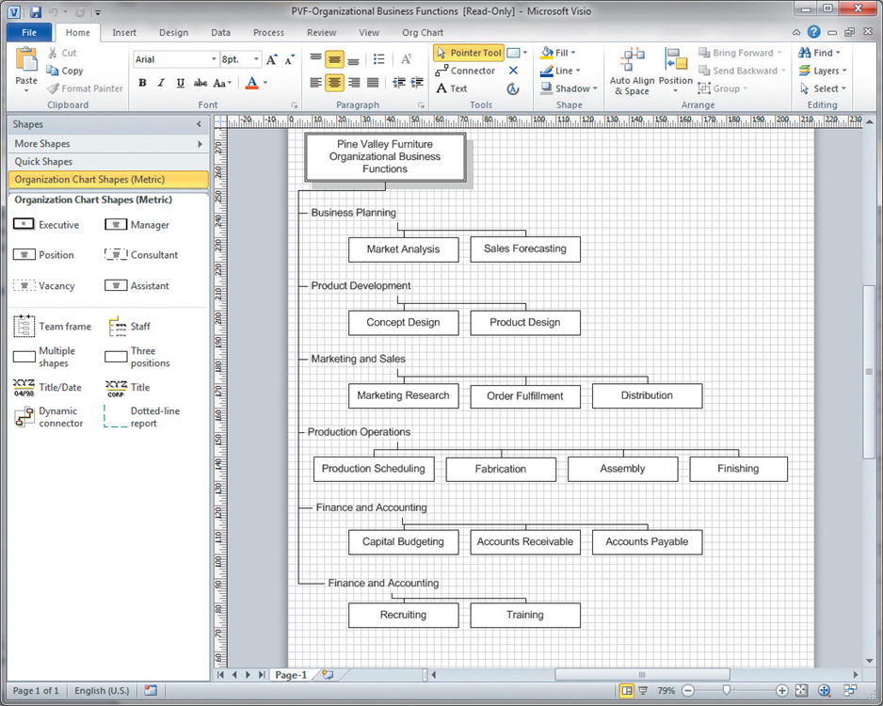

* + **IS planning matrices** describe relationships between pairs of organizational elements (location, function, business unit, objective, process, data, information system).
  + Types of Planning Matrices
* Location-to-Function
* Location-to-Unit
* Unit-to-Function
* Function-to-Objective
* Function-to-Process
* Function-to-Data Entity
* Process-to-Data Entity
* Process-to-Information System
* Data Entity-to-Information System
* Information System-to-Objective

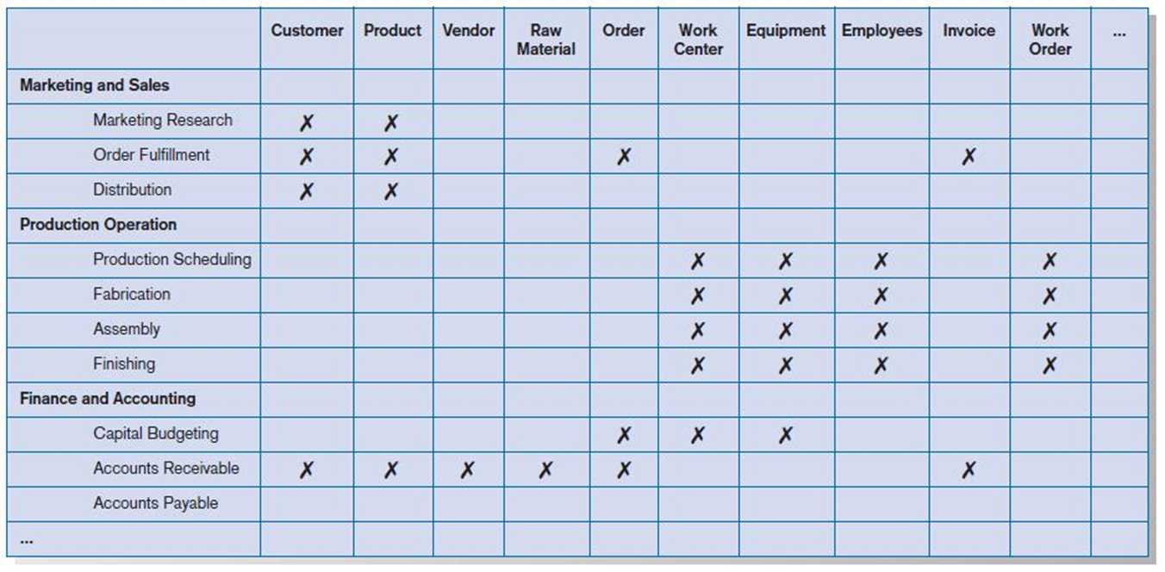

1. **Describing The Target Situation, Trends, and Constraints**
   * The target situation consists of the desired state of locations, functions, units, processes, data, and IS

* Most lists and matrices will need to be updated to reflect this version
* The target situation must be developed in light of technology and business trends, in addition to organizational constraints

1. **IS Plan Components**
   * Organizational Mission, Objectives, and Strategy

* Brief description of mission, objectives, and strategy of the organization
  + Information Inventory
* Summary of processes, functions, data entities, and information needs of the enterprise
  + Mission and Objectives of IS
* Primary role IS will play in the organization to transform enterprise from current to future state
  + Constraints on IS Development
* Limitations imposed by technology and current levels of financial, technical, and personnel resources
  + Systems Needs and IS Strategy
* Summarize overall IS needs in the company and set long-term (2-5 year) strategies for filling the needs
  + Short Term Plan
* Detailed inventory of present projects and systems and detailed plan for the current year
  + Conclusions
* Unknown but likely events that can affect the plan, presently known business change elements and their impact on the 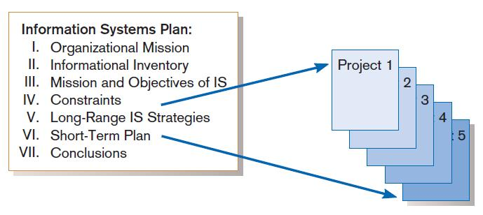plan

1. **Electronic Commerce Applications and Internet Basics**
   * **Internet:** a large worldwide network of networks that use a common protocol to communicate with each other
   * **Electronic Commerce (EC):** Internet-based communication to support day-to-day business activities
   * **Business-to-consumer (B2C):** electronic commerce between businesses and consumers
   * **Business-to-business (B2B):** electronic commerce between business partners, such as suppliers and intermediaries
   * **Business-to-employee (B2E):** electronic commerce between businesses and their employees
   * 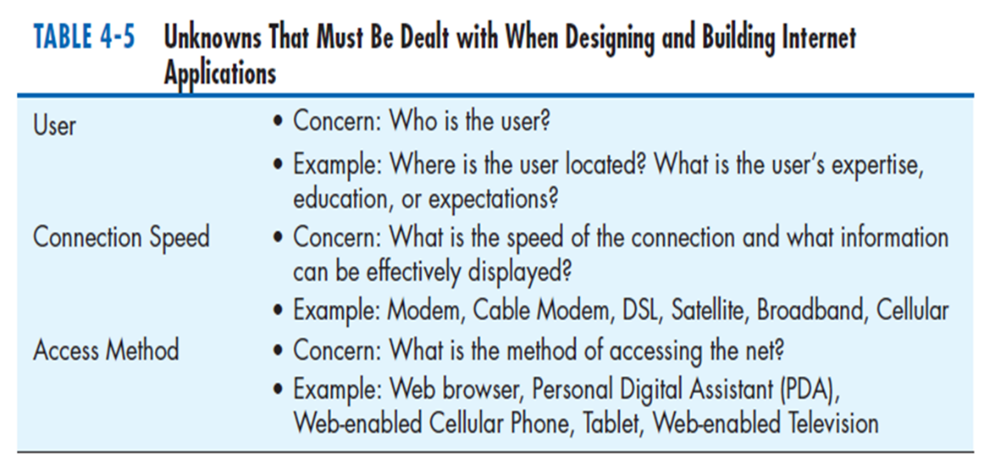**Electronic data interchange (EDI):** the use of telecommunications technologies to directly transfer business documents between organizations